Setting up the WEB IDE Account?

SAP Web IDE is online development tool which run on browser. So before using it we need to setup the Web IDE account.

[Setup Process](http://www.fioritutorials.com/webide/webide-setup.html#collapseTwo)

Open the Link : [https://account.hanatrial.ondemand.com](https://account.hanatrial.ondemand.com/) on browser.

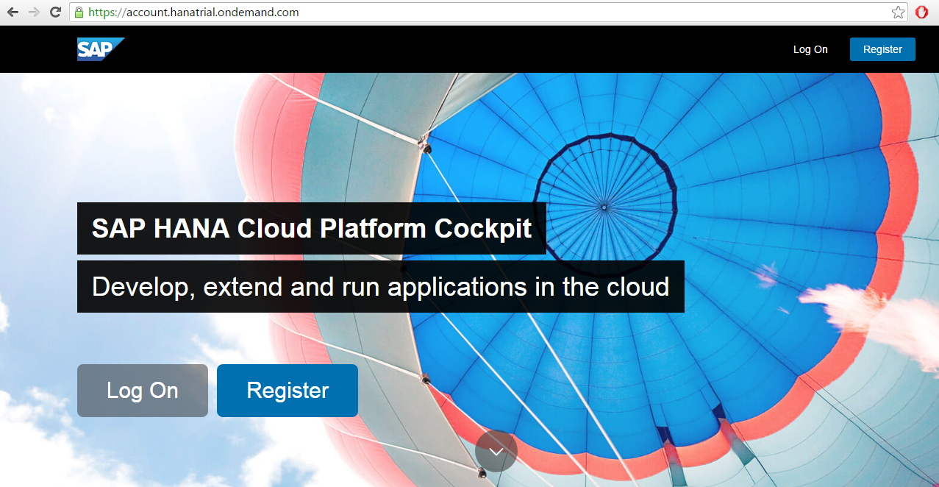

Now click on register button and register your account.

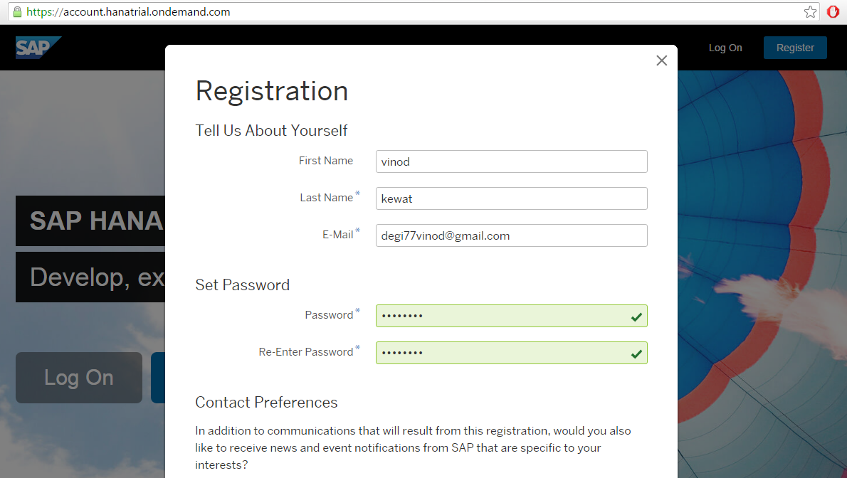

Now you will get a mail for activating your account. Click on 'Activate Your Account' button.

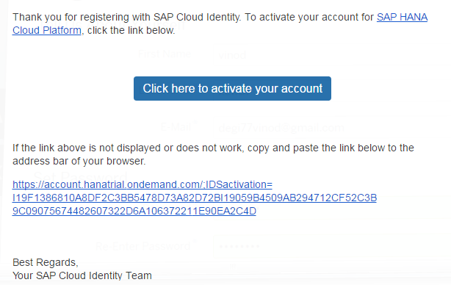

After clicking on activation link you will get following screen.Now close the pop up.

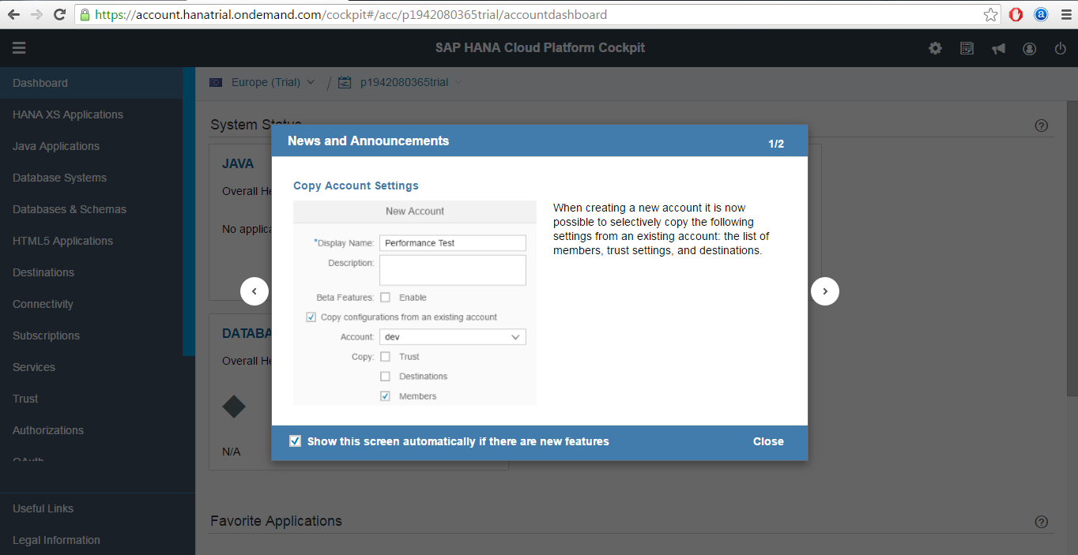

Now click on the 'Subscription' tab on left side. You will get the following screen.

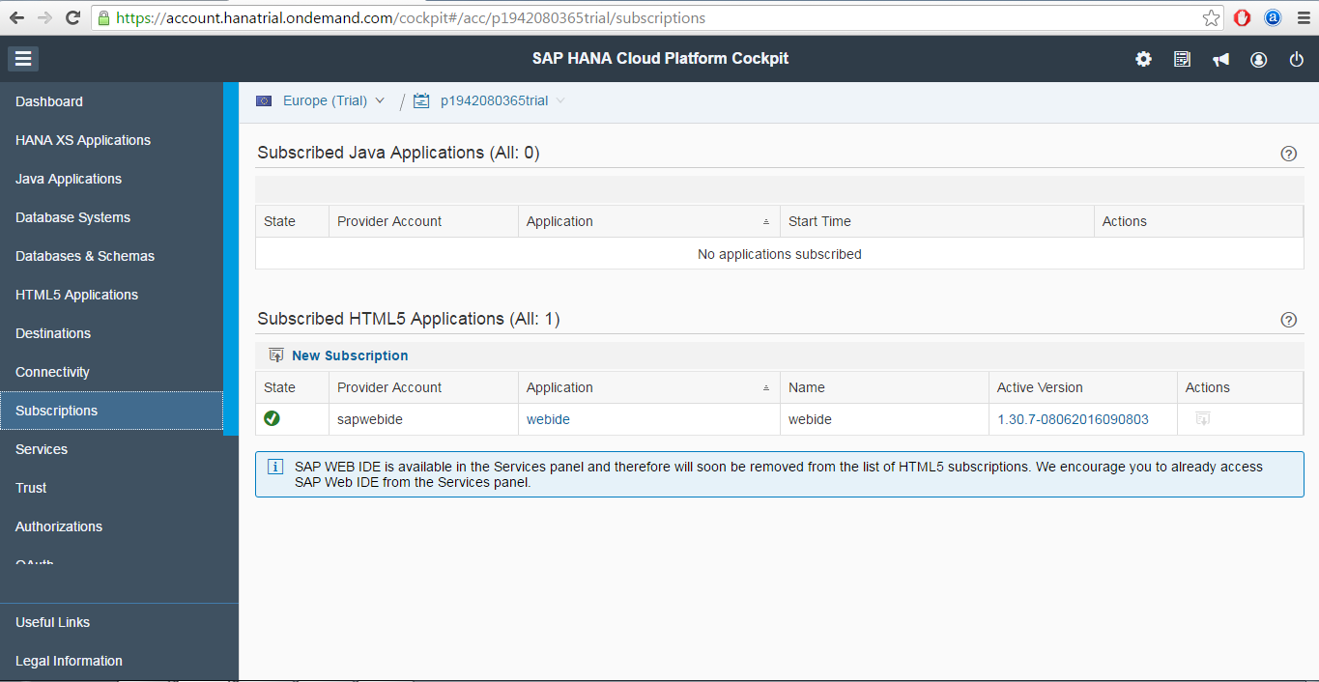

Now click on the Web IDE link you will get the Application URL of Web IDE. Now open this URL in New tab.

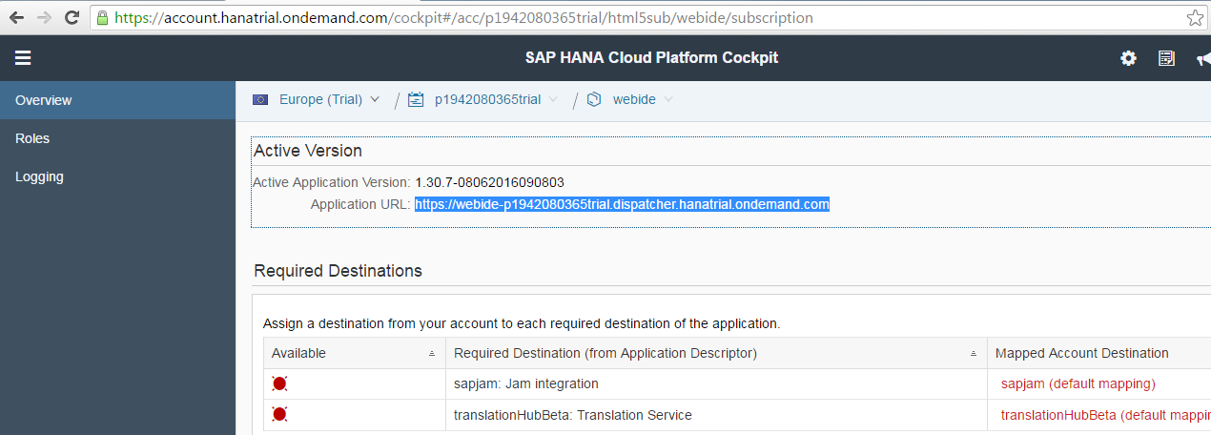

Bootmark the Web IDE URL so that you don't have to logged in to hana trial account and open Web IDE from there. Now this is what initial screen will look like.

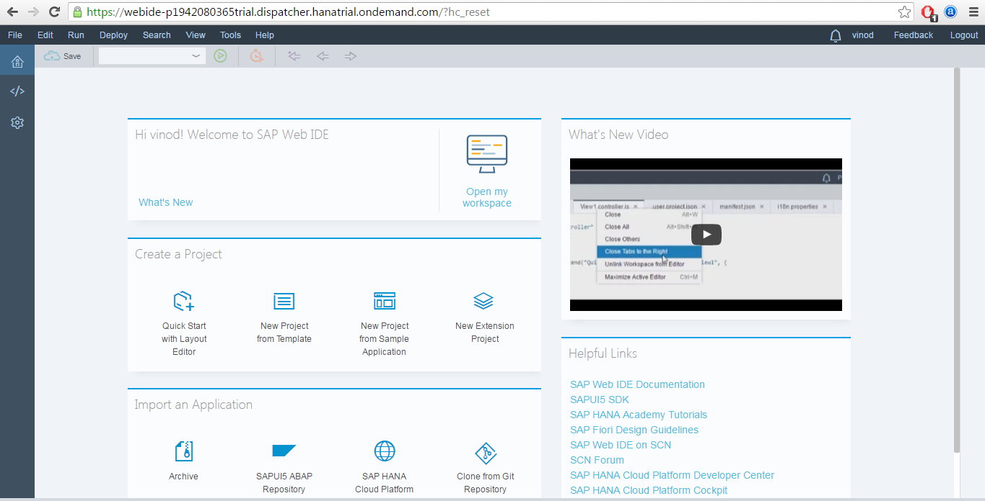

Now click on the development tab '< />'. This is where you will do the actual development work.

